**Overview:**

In this project, I have decided to create a database for Northeastern University’s Sports portal.College sports is a very important part of our university culture. Starting with soccer, ice-hockey till basketball and baseball there are several sports activities. The university authorities need to maintain data and information of the entire organization structure for their managerial conduct and to improve the overall performance of the teams.

**Scope and approach:**

It will not only just help us to systematically analyze the sports department of the university, but also help us to distinguish different departments. There are a lot of departments under Northeastern University sports section. This database will have different ecosystem/entities. Each department can have their different table with unique attributes. Then there is a department to manage all these sports, it can have its own table too. Other than departments there are coaches, sponsors, athletes and other employers too.

**Problem Statement:**

Managing and Analysis on data of the entire organization including teams, health department, sponsors and broadcasting partners is a challenging task. There should be a systematical organization flow between all entities. Deciding their hierarchy can be a tedious task.

**Entities:**

* Matches
* Sports
* Time
* Seats
* Stadium
* Team
* Players
* Coach
* TicketBooking
* Customer
* Team has players
* Team has coach

**ER Diagram:**

Initial Stages

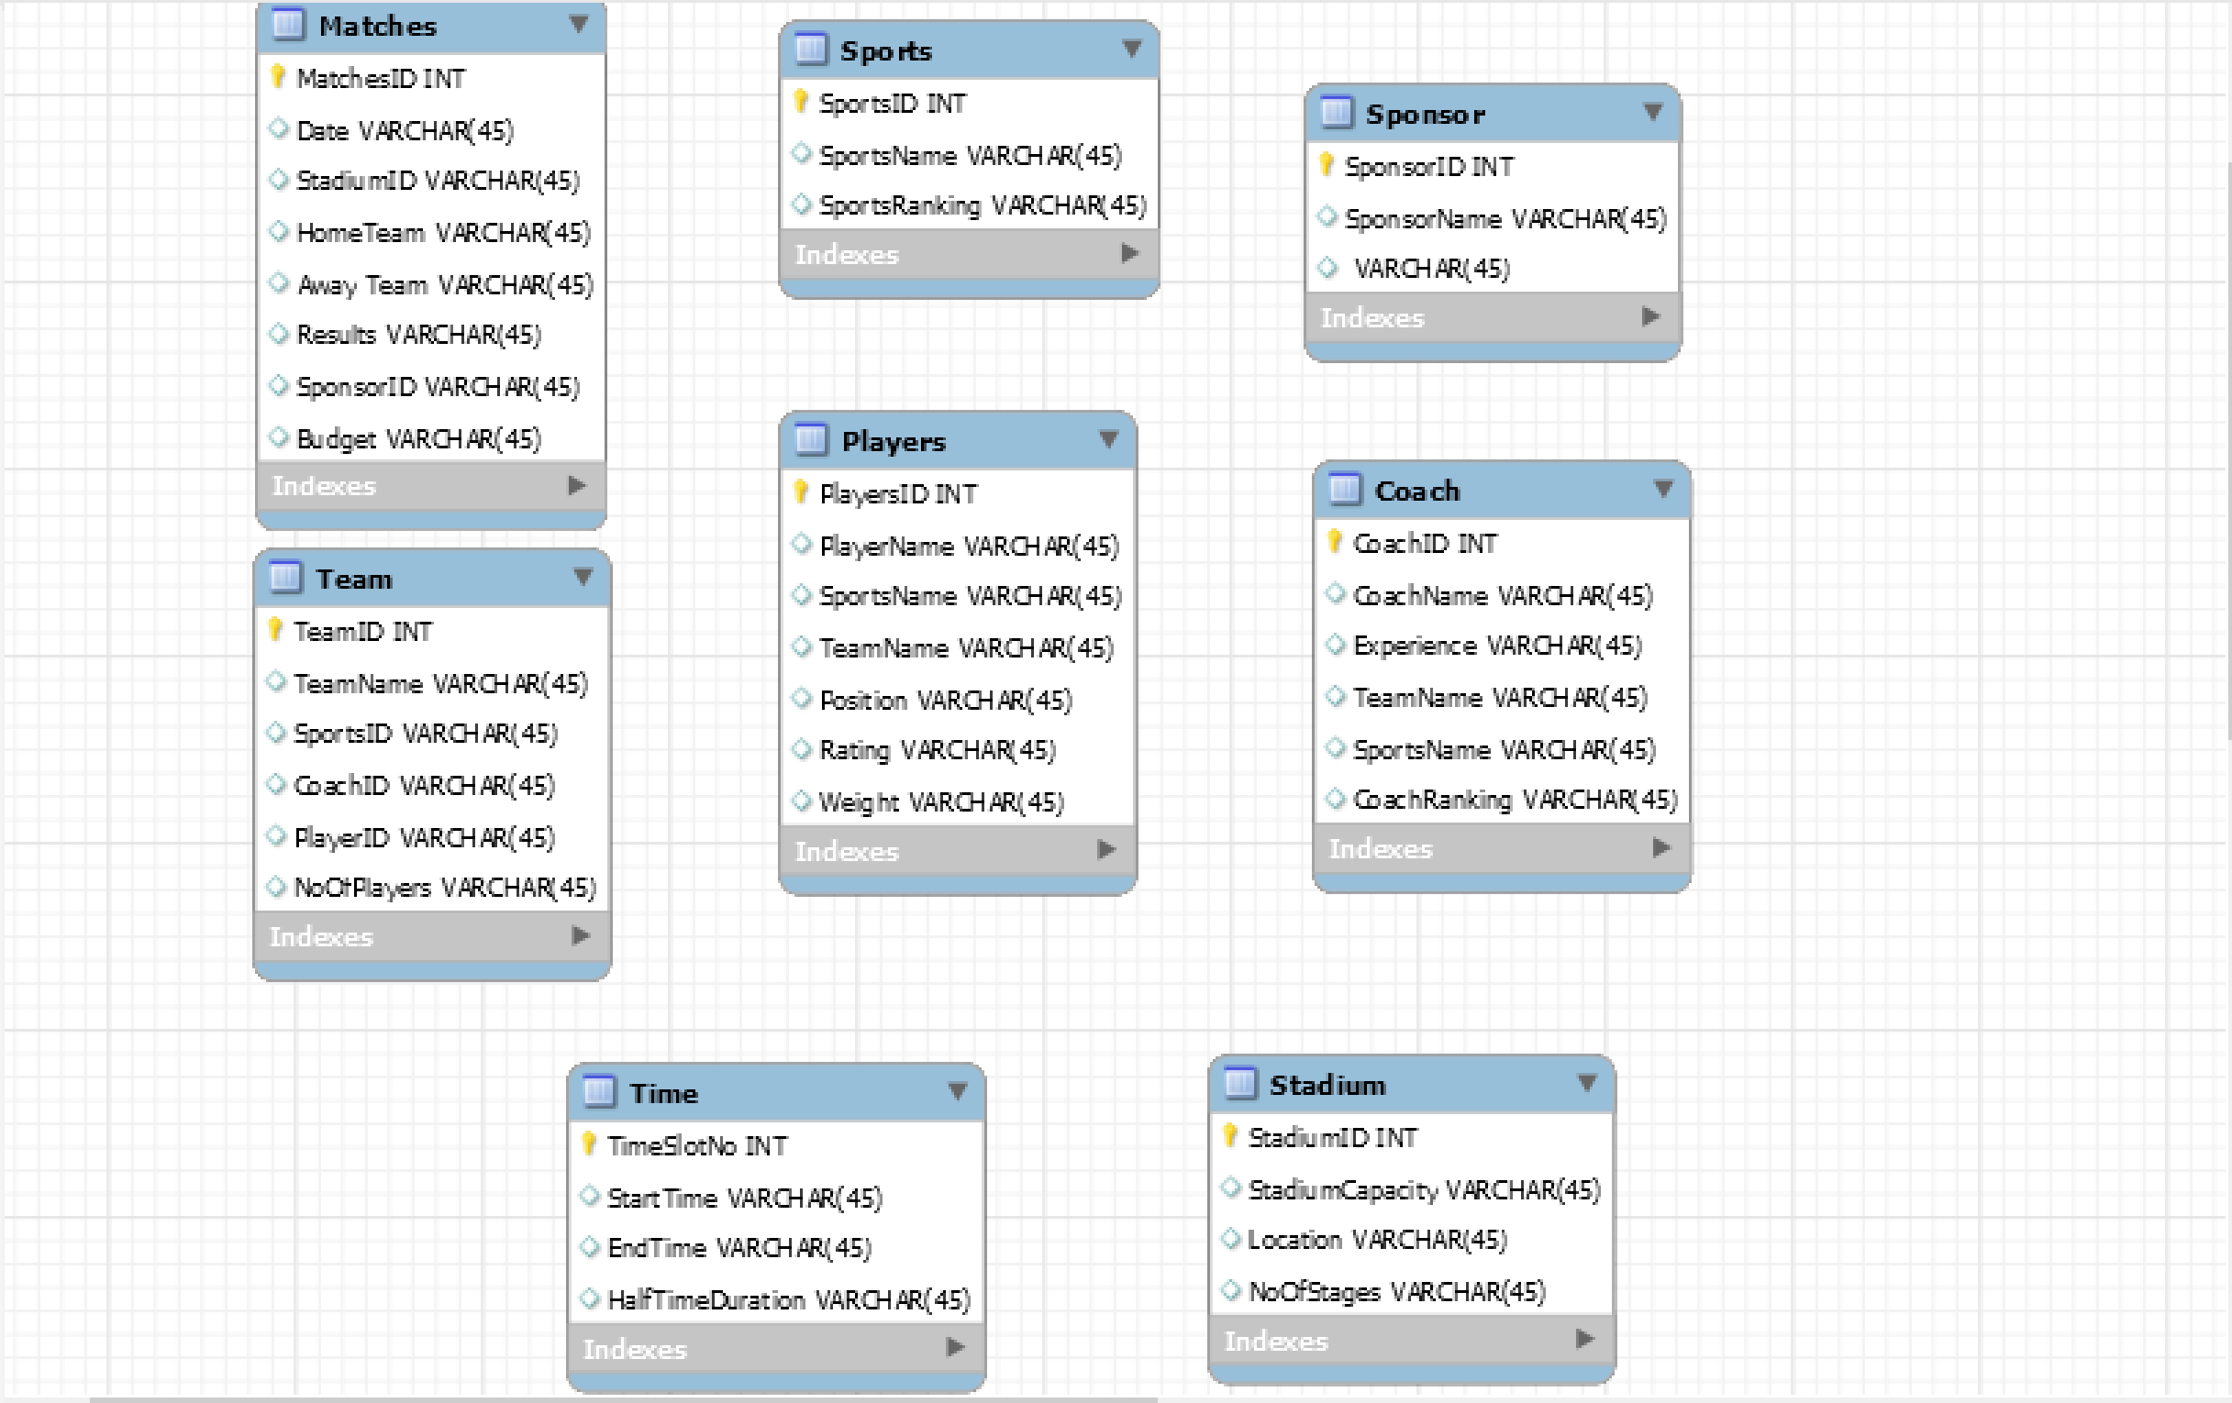

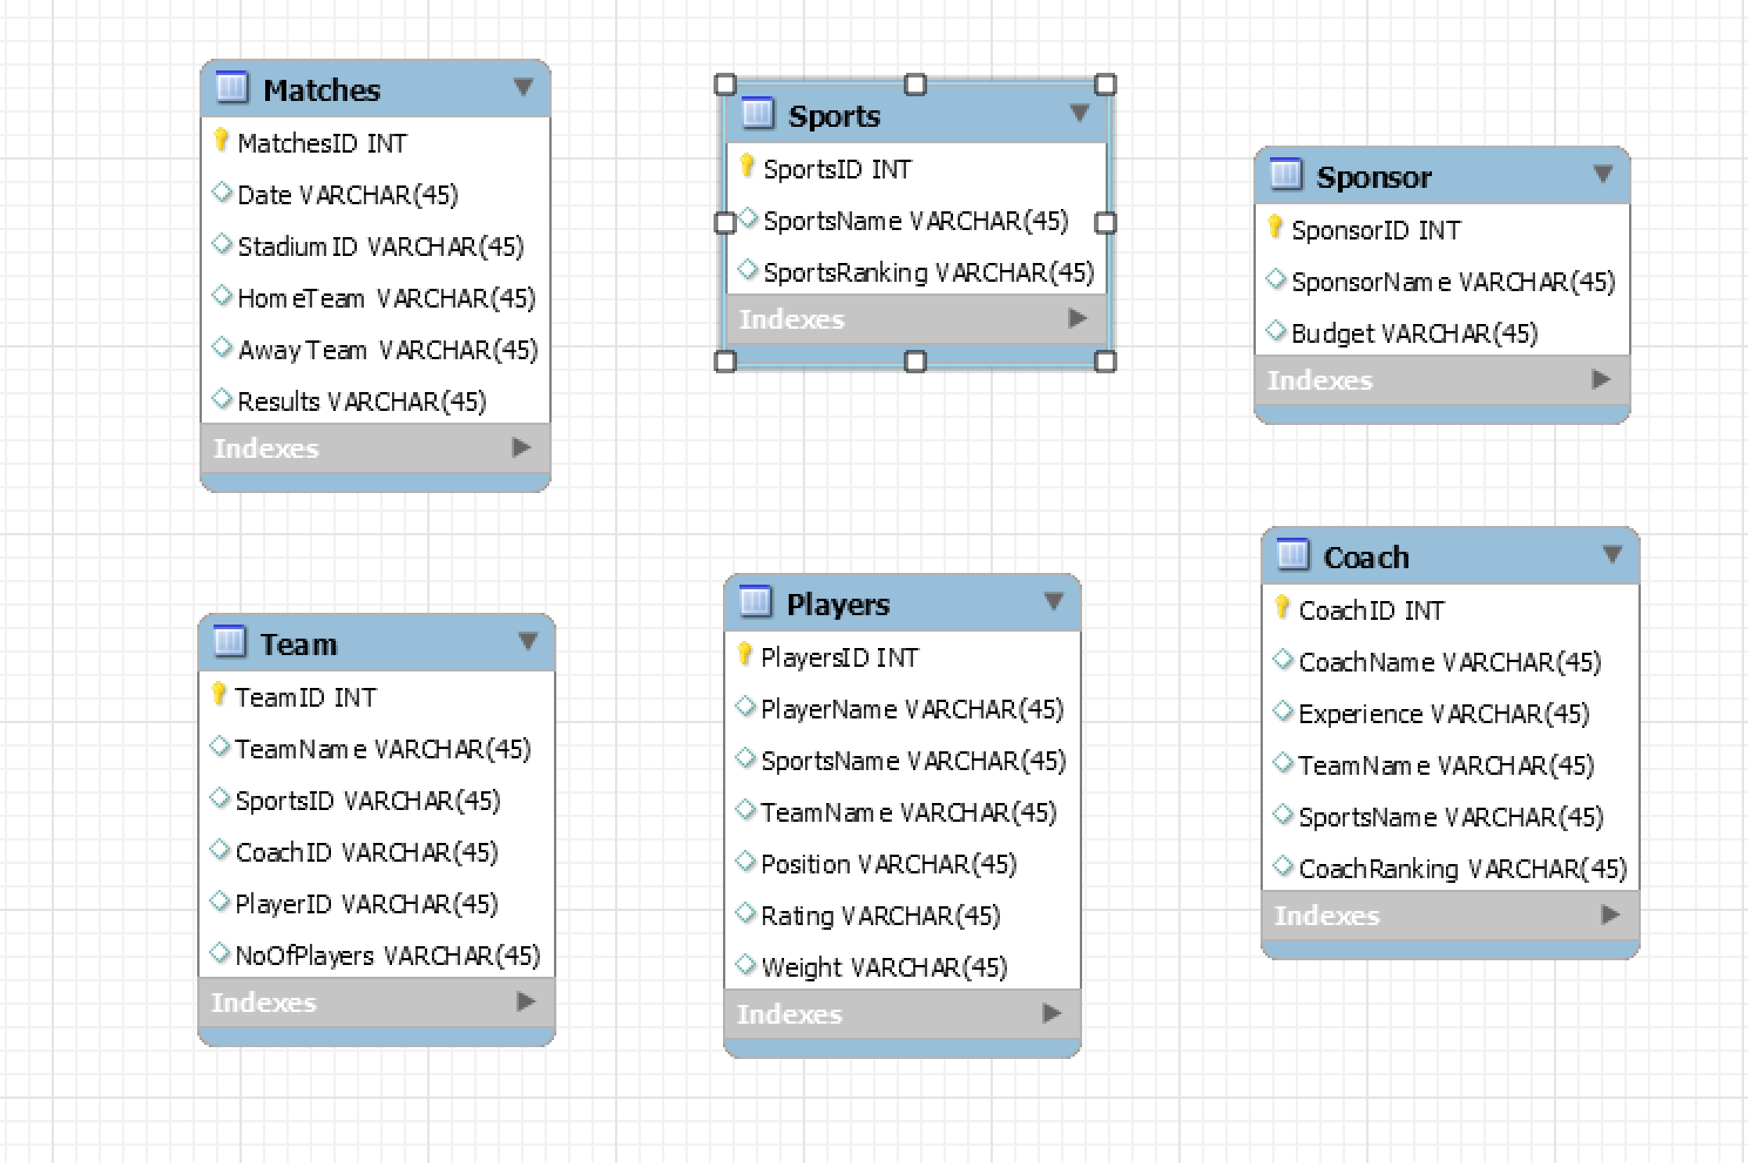

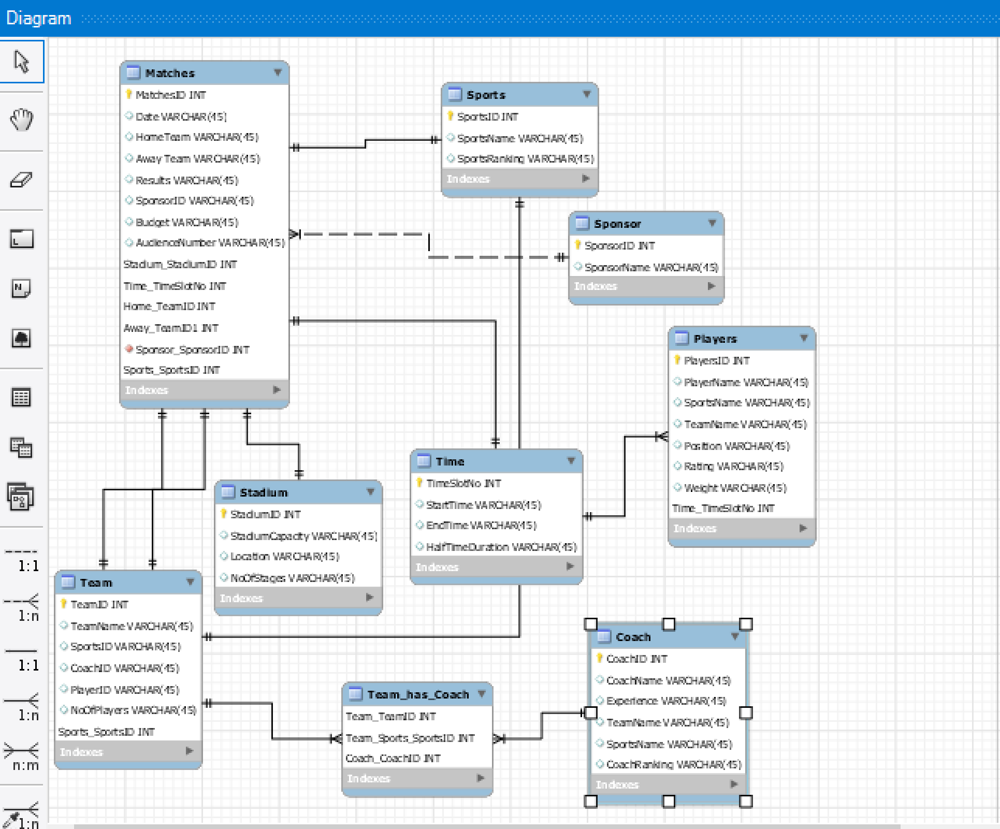

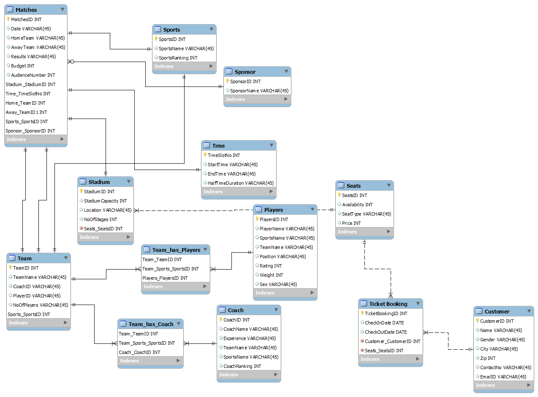Final ER diagram:

Views and Procedures:

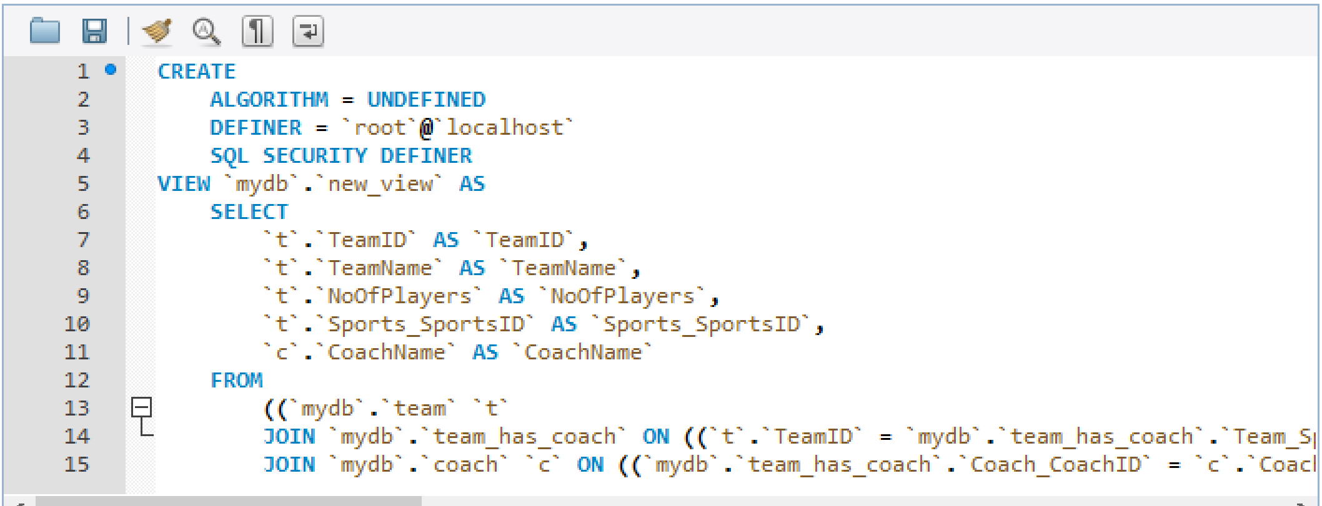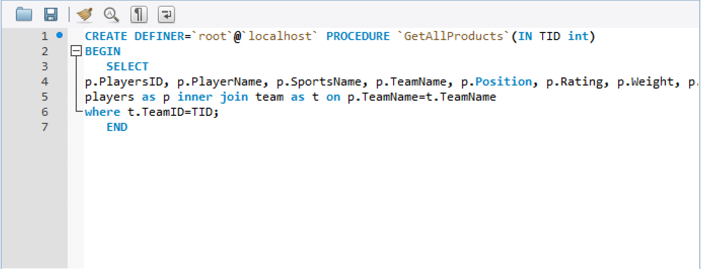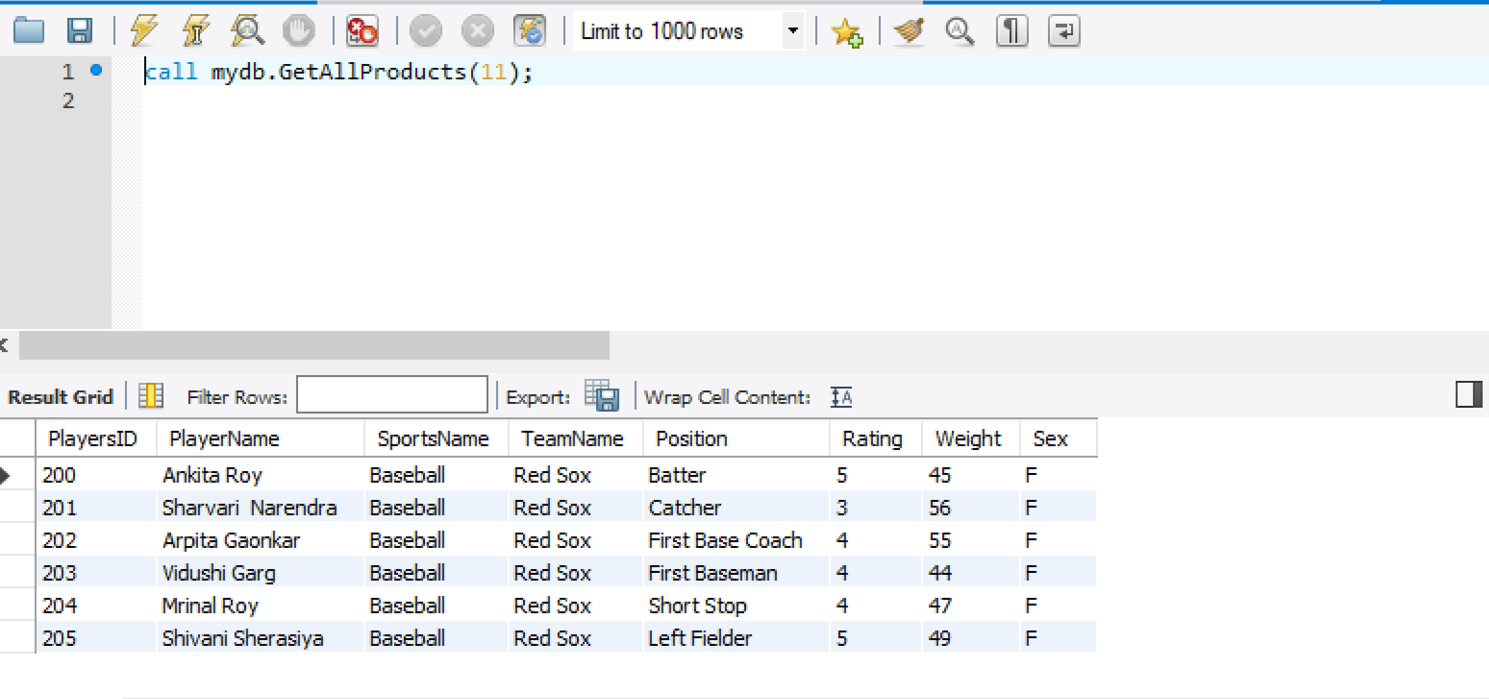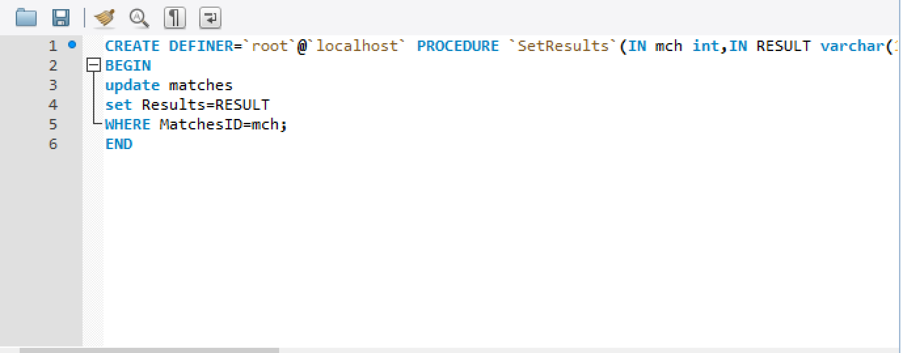

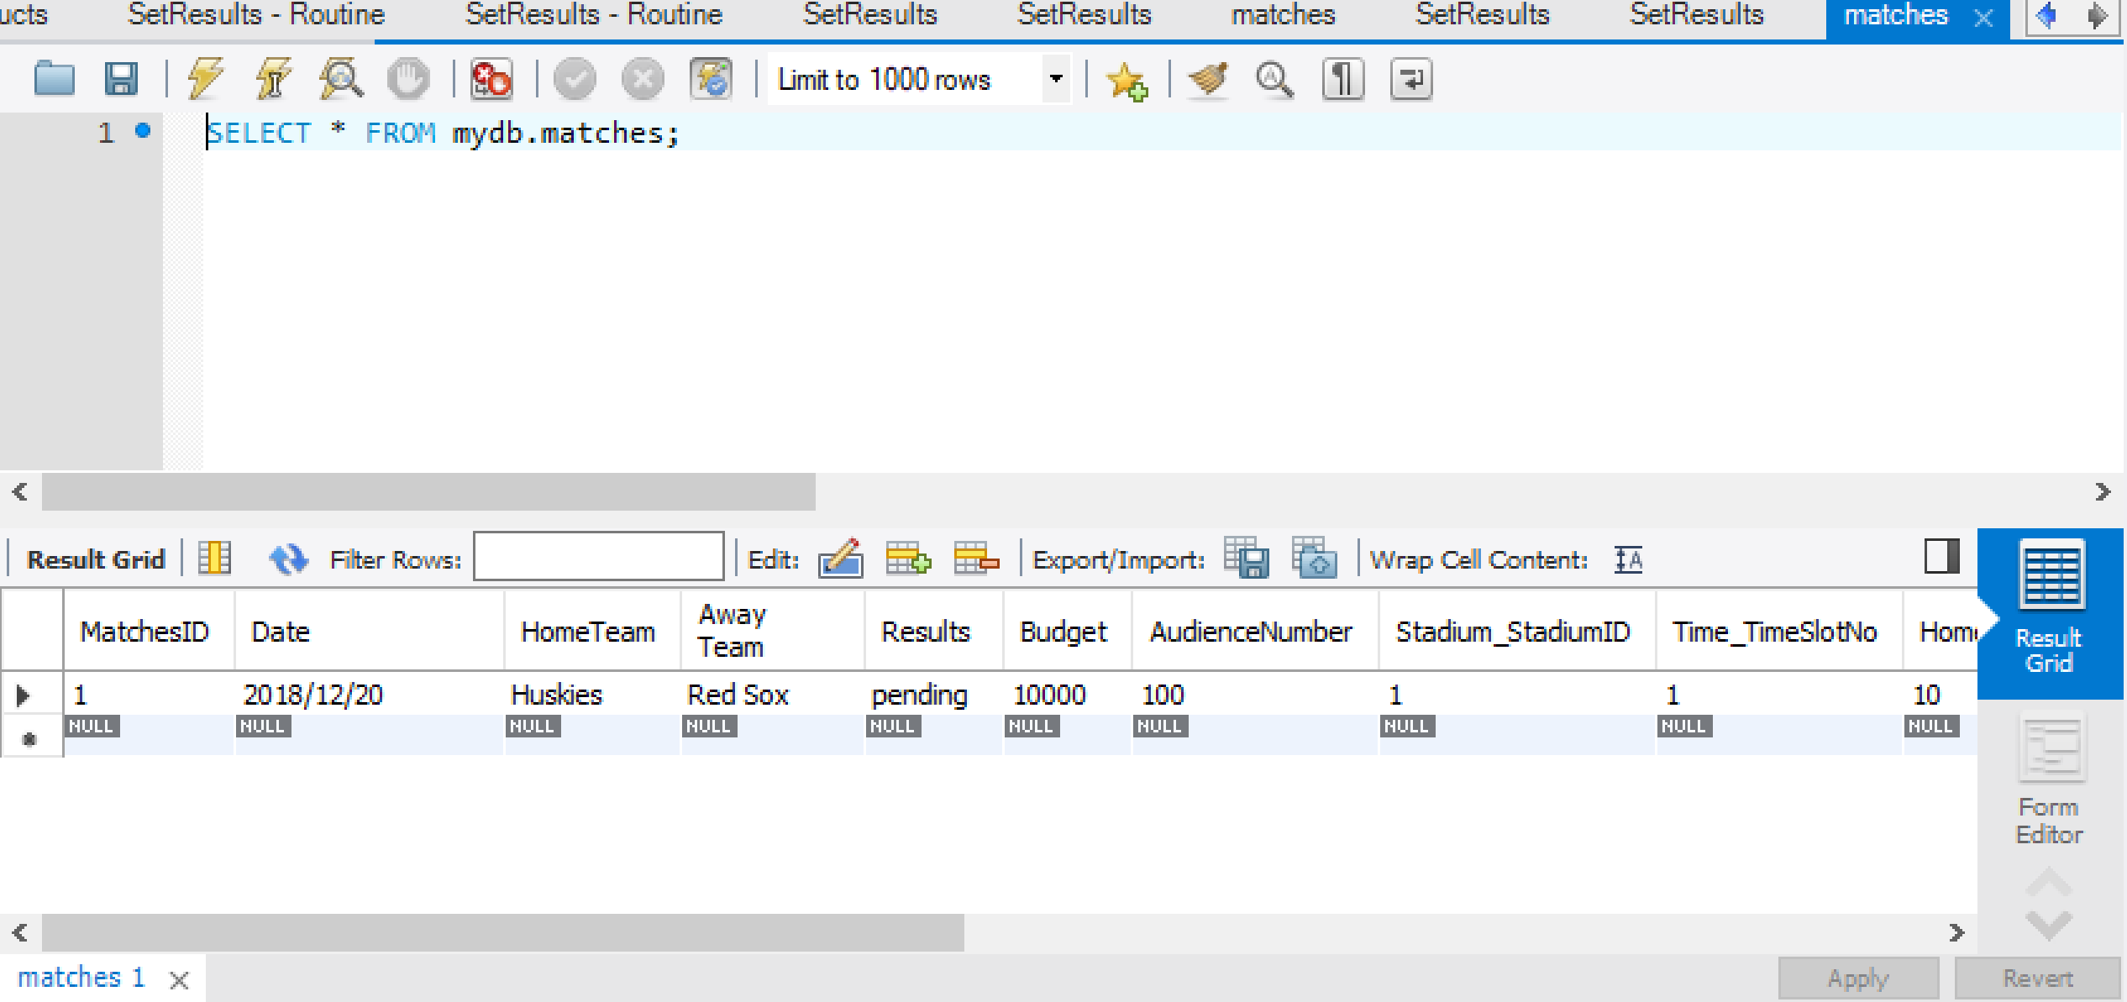

**Project Dump:**

CREATE DATABASE IF NOT EXISTS `mydb` /*!40100 DEFAULT CHARACTER SET utf8 */;

USE `mydb`;

-- MySQL dump 10.13 Distrib 8.0.12, for Win64 (x86_64)

--

-- Host: localhost Database: mydb

-- ------------------------------------------------------

-- Server version 8.0.12

/*!40101 SET @OLD_CHARACTER_SET_CLIENT=@@CHARACTER_SET_CLIENT */;

/*!40101 SET @OLD_CHARACTER_SET_RESULTS=@@CHARACTER_SET_RESULTS */;

/*!40101 SET @OLD_COLLATION_CONNECTION=@@COLLATION_CONNECTION */;

SET NAMES utf8 ;

/*!40103 SET @OLD_TIME_ZONE=@@TIME_ZONE */;

/*!40103 SET TIME_ZONE='+00:00' */;

/*!40014 SET @OLD_UNIQUE_CHECKS=@@UNIQUE_CHECKS, UNIQUE_CHECKS=0 */;

/*!40014 SET @OLD_FOREIGN_KEY_CHECKS=@@FOREIGN_KEY_CHECKS, FOREIGN_KEY_CHECKS=0 */;

/*!40101 SET @OLD_SQL_MODE=@@SQL_MODE, SQL_MODE='NO_AUTO_VALUE_ON_ZERO' */;

/*!40111 SET @OLD_SQL_NOTES=@@SQL_NOTES, SQL_NOTES=0 */;

--

-- Table structure for table `coach`

--

DROP TABLE IF EXISTS `coach`;

/*!40101 SET @saved_cs_client = @@character_set_client */;

SET character_set_client = utf8mb4 ;

CREATE TABLE `coach` (

`CoachID` int(11) NOT NULL,

`CoachName` varchar(45) DEFAULT NULL,

`Experience` varchar(45) DEFAULT NULL,

`TeamName` varchar(45) DEFAULT NULL,

`SportsName` varchar(45) DEFAULT NULL,

`CoachRanking` int(11) DEFAULT NULL,

PRIMARY KEY (`CoachID`)

) ENGINE=InnoDB DEFAULT CHARSET=utf8;

/*!40101 SET character_set_client = @saved_cs_client */;

--

-- Dumping data for table `coach`

--

LOCK TABLES `coach` WRITE;

/*!40000 ALTER TABLE `coach` DISABLE KEYS */;

INSERT INTO `coach` VALUES (1001,'Khaled Bugrara','21','NEU','Table Tennis',5),(1002,'Yusuf Ozbek','20','Huskies','Baseball',5);

/*!40000 ALTER TABLE `coach` ENABLE KEYS */;

UNLOCK TABLES;

--

-- Table structure for table `customer`

--

DROP TABLE IF EXISTS `customer`;

/*!40101 SET @saved_cs_client = @@character_set_client */;

SET character_set_client = utf8mb4 ;

CREATE TABLE `customer` (

`CustomerID` int(11) NOT NULL,

`Name` varchar(45) DEFAULT NULL,

`Gender` varchar(45) DEFAULT NULL,

`City` varchar(45) DEFAULT NULL,

`Zip` int(11) DEFAULT NULL,

`ContactNo` varchar(45) DEFAULT NULL,

`EmailID` varchar(45) DEFAULT NULL,

PRIMARY KEY (`CustomerID`)

) ENGINE=InnoDB DEFAULT CHARSET=utf8;

/*!40101 SET character_set_client = @saved_cs_client */;

--

-- Dumping data for table `customer`

--

LOCK TABLES `customer` WRITE;

/*!40000 ALTER TABLE `customer` DISABLE KEYS */;

INSERT INTO `customer` VALUES (1,'Mihir Swant','M','Boston',2115,'5665522222','mihirsawant@gmail.com'),(2,'Shubha Arolkar','F','Boston',2115,'5665522223','shubha@gmail.com'),(3,'Arun Arolkar','M','Boston',2115,'5665522224','arun@gmail.com');

/*!40000 ALTER TABLE `customer` ENABLE KEYS */;

UNLOCK TABLES;

--

-- Table structure for table `matches`

--

DROP TABLE IF EXISTS `matches`;

/*!40101 SET @saved_cs_client = @@character_set_client */;

SET character_set_client = utf8mb4 ;

CREATE TABLE `matches` (

`MatchesID` int(11) NOT NULL,

`Date` varchar(45) DEFAULT NULL,

`HomeTeam` varchar(45) DEFAULT NULL,

`Away Team` varchar(45) DEFAULT NULL,

`Results` varchar(45) DEFAULT NULL COMMENT 'To keep track of Matches \n',

`Budget` int(11) DEFAULT NULL,

`AudienceNumber` int(11) DEFAULT NULL,

`Stadium_StadiumID` int(11) NOT NULL,

`Time_TimeSlotNo` int(11) NOT NULL,

`Home_TeamID` int(11) NOT NULL,

`Away_TeamID1` int(11) NOT NULL,

`Sports_SportsID` int(11) NOT NULL,

`Sponsor_SponsorID` int(11) NOT NULL,

`TotalMatchDuration` time DEFAULT NULL,

`Home_Team_Sports_SportsID` int(11) DEFAULT NULL,

`Away_Team_Sports_SportsID1` int(11) DEFAULT NULL,

PRIMARY KEY (`MatchesID`,`Stadium_StadiumID`,`Time_TimeSlotNo`,`Home_TeamID`,`Away_TeamID1`,`Sports_SportsID`,`Sponsor_SponsorID`),

KEY `fk_Matches_Stadium1_idx` (`Stadium_StadiumID`),

KEY `fk_Matches_Time1_idx` (`Time_TimeSlotNo`),

KEY `fk_Matches_Team1_idx` (`Home_TeamID`),

KEY `fk_Matches_Team2_idx` (`Away_TeamID1`),

KEY `fk_Matches_Sports1_idx` (`Sports_SportsID`),

KEY `fk_Matches_Sponsor1_idx` (`Sponsor_SponsorID`),

KEY `Away_Team_Sports_SportsID1_idx` (`Away_Team_Sports_SportsID1`),

KEY `Home_Team_Sports_SportsID_idx` (`Home_Team_Sports_SportsID`),

CONSTRAINT `Away_Team_Sports_SportsID1` FOREIGN KEY (`Away_Team_Sports_SportsID1`) REFERENCES `team` (`sports_sportsid`),

CONSTRAINT `Home_Team_Sports_SportsID` FOREIGN KEY (`Home_Team_Sports_SportsID`) REFERENCES `team` (`sports_sportsid`),

CONSTRAINT `fk_Matches_Sponsor1` FOREIGN KEY (`Sponsor_SponsorID`) REFERENCES `sponsor` (`sponsorid`),

CONSTRAINT `fk_Matches_Sports1` FOREIGN KEY (`Sports_SportsID`) REFERENCES `sports` (`sportsid`),

CONSTRAINT `fk_Matches_Stadium1` FOREIGN KEY (`Stadium_StadiumID`) REFERENCES `stadium` (`stadiumid`),

CONSTRAINT `fk_Matches_Team1` FOREIGN KEY (`Home_TeamID`) REFERENCES `team` (`teamid`),

CONSTRAINT `fk_Matches_Team2` FOREIGN KEY (`Away_TeamID1`) REFERENCES `team` (`teamid`),

CONSTRAINT `fk_Matches_Time1` FOREIGN KEY (`Time_TimeSlotNo`) REFERENCES `time` (`timeslotno`)

) ENGINE=InnoDB DEFAULT CHARSET=utf8;

/*!40101 SET character_set_client = @saved_cs_client */;

--

-- Dumping data for table `matches`

--

LOCK TABLES `matches` WRITE;

/*!40000 ALTER TABLE `matches` DISABLE KEYS */;

INSERT INTO `matches` VALUES (1,'2018/12/20','Huskies','Red Sox','pending',10000,100,1,1,10,11,2000,20,'00:50:00',2000,2000);

/*!40000 ALTER TABLE `matches` ENABLE KEYS */;

UNLOCK TABLES;

--

-- Temporary view structure for view `new_view`

--

DROP TABLE IF EXISTS `new_view`;

/*!50001 DROP VIEW IF EXISTS `new_view`*/;

SET @saved_cs_client = @@character_set_client;

SET character_set_client = utf8mb4;

/*!50001 CREATE VIEW `new_view` AS SELECT

1 AS `TeamID`,

1 AS `TeamName`,

1 AS `NoOfPlayers`,

1 AS `Sports_SportsID`,

1 AS `CoachName`*/;

SET character_set_client = @saved_cs_client;

--

-- Table structure for table `players`

--

DROP TABLE IF EXISTS `players`;

/*!40101 SET @saved_cs_client = @@character_set_client */;

SET character_set_client = utf8mb4 ;

CREATE TABLE `players` (

`PlayersID` int(11) NOT NULL,

`PlayerName` varchar(45) DEFAULT NULL,

`SportsName` varchar(45) DEFAULT NULL,

`TeamName` varchar(45) DEFAULT NULL,

`Position` varchar(45) DEFAULT NULL,

`Rating` int(11) DEFAULT NULL,

`Weight` int(11) DEFAULT NULL,

`Sex` varchar(45) DEFAULT NULL,

PRIMARY KEY (`PlayersID`)

) ENGINE=InnoDB DEFAULT CHARSET=utf8;

/*!40101 SET character_set_client = @saved_cs_client */;

--

-- Dumping data for table `players`

--

LOCK TABLES `players` WRITE;

/*!40000 ALTER TABLE `players` DISABLE KEYS */;

INSERT INTO `players` VALUES (100,'Chinmay Arolkar','Baseball','Huskies','Batter',5,72,'M'),(101,'Abhishek Kamble','Baseball','Huskies','Catcher',4,55,'M'),(102,'Swapnil Deshpande','Baseball','Huskies','First Base Coach',5,45,'M'),(103,'Yash Shinde','Baseball','Huskies','First Baseman',3,56,'M'),(104,'Sumit Anglekar','Baseball','Huskies','Short Stop',5,67,'M'),(105,'Apoorva Dudhe','Baseball','Huskies','Left Fielder',4,78,'M'),(200,'Ankita Roy','Baseball','Red Sox','Batter',5,45,'F'),(201,'Sharvari Narendra','Baseball','Red Sox','Catcher',3,56,'F'),(202,'Arpita Gaonkar','Baseball','Red Sox','First Base Coach',4,55,'F'),(203,'Vidushi Garg','Baseball','Red Sox','First Baseman',4,44,'F'),(204,'Mrinal Roy','Baseball','Red Sox','Short Stop',4,47,'F'),(205,'Shivani Sherasiya','Baseball','Red Sox','Left Fielder',5,49,'F');

/*!40000 ALTER TABLE `players` ENABLE KEYS */;

UNLOCK TABLES;

--

-- Table structure for table `seats`

--

DROP TABLE IF EXISTS `seats`;

/*!40101 SET @saved_cs_client = @@character_set_client */;

SET character_set_client = utf8mb4 ;

CREATE TABLE `seats` (

`SeatsID` int(11) NOT NULL,

`Availability` int(11) DEFAULT NULL,

`SeatType` varchar(45) DEFAULT NULL,

`Price` int(11) DEFAULT NULL,

`Stadium_StadiumID1` int(11) DEFAULT NULL,

`BookedBy` int(11) DEFAULT NULL,

PRIMARY KEY (`SeatsID`),

KEY `Stadium_StadiumID_idx` (`Stadium_StadiumID1`),

KEY `CustomerID_idx` (`BookedBy`),

CONSTRAINT `BookedBy` FOREIGN KEY (`BookedBy`) REFERENCES `customer` (`customerid`),

CONSTRAINT `Stadium_StadiumID` FOREIGN KEY (`Stadium_StadiumID1`) REFERENCES `stadium` (`stadiumid`)

) ENGINE=InnoDB DEFAULT CHARSET=utf8;

/*!40101 SET character_set_client = @saved_cs_client */;

--

-- Dumping data for table `seats`

--

LOCK TABLES `seats` WRITE;

/*!40000 ALTER TABLE `seats` DISABLE KEYS */;

INSERT INTO `seats` VALUES (1,0,'Regular',10,1,NULL),(2,1,'Regular',10,1,NULL),(3,1,'Regular',10,1,NULL),(4,1,'Premium',8,1,NULL),(5,1,'Premium',8,1,NULL);

/*!40000 ALTER TABLE `seats` ENABLE KEYS */;

UNLOCK TABLES;

--

-- Table structure for table `sponsor`

--

DROP TABLE IF EXISTS `sponsor`;

/*!40101 SET @saved_cs_client = @@character_set_client */;

SET character_set_client = utf8mb4 ;

CREATE TABLE `sponsor` (

`SponsorID` int(11) NOT NULL,

`SponsorName` varchar(45) DEFAULT NULL,

PRIMARY KEY (`SponsorID`)

) ENGINE=InnoDB DEFAULT CHARSET=utf8;

/*!40101 SET character_set_client = @saved_cs_client */;

--

-- Dumping data for table `sponsor`

--

LOCK TABLES `sponsor` WRITE;

/*!40000 ALTER TABLE `sponsor` DISABLE KEYS */;

INSERT INTO `sponsor` VALUES (20,'CocaCola'),(21,'Dunkin Donuts');

/*!40000 ALTER TABLE `sponsor` ENABLE KEYS */;

UNLOCK TABLES;

--

-- Table structure for table `sports`

--

DROP TABLE IF EXISTS `sports`;

/*!40101 SET @saved_cs_client = @@character_set_client */;

SET character_set_client = utf8mb4 ;

CREATE TABLE `sports` (

`SportsID` int(11) NOT NULL,

`SportsName` varchar(45) DEFAULT NULL,

`SportsRanking` int(11) DEFAULT NULL,

PRIMARY KEY (`SportsID`)

) ENGINE=InnoDB DEFAULT CHARSET=utf8;

/*!40101 SET character_set_client = @saved_cs_client */;

--

-- Dumping data for table `sports`

--

LOCK TABLES `sports` WRITE;

/*!40000 ALTER TABLE `sports` DISABLE KEYS */;

INSERT INTO `sports` VALUES (2000,'Baseball',1),(2001,'Table Tennis',2);

/*!40000 ALTER TABLE `sports` ENABLE KEYS */;

UNLOCK TABLES;

--

-- Table structure for table `stadium`

--

DROP TABLE IF EXISTS `stadium`;

/*!40101 SET @saved_cs_client = @@character_set_client */;

SET character_set_client = utf8mb4 ;

CREATE TABLE `stadium` (

`StadiumID` int(11) NOT NULL,

`StadiumCapacity` int(11) DEFAULT NULL,

`Location` varchar(45) DEFAULT NULL,

`NoOfStages` int(11) DEFAULT NULL,

PRIMARY KEY (`StadiumID`)

) ENGINE=InnoDB DEFAULT CHARSET=utf8;

/*!40101 SET character_set_client = @saved_cs_client */;

--

-- Dumping data for table `stadium`

--

LOCK TABLES `stadium` WRITE;

/*!40000 ALTER TABLE `stadium` DISABLE KEYS */;

INSERT INTO `stadium` VALUES (1,1000,'Fenway Park',3),(2,100,'Brookline Avenue',1);

/*!40000 ALTER TABLE `stadium` ENABLE KEYS */;

UNLOCK TABLES;

--

-- Table structure for table `team`

--

DROP TABLE IF EXISTS `team`;

/*!40101 SET @saved_cs_client = @@character_set_client */;

SET character_set_client = utf8mb4 ;

CREATE TABLE `team` (

`TeamID` int(11) NOT NULL,

`TeamName` varchar(45) DEFAULT NULL,

`NoOfPlayers` varchar(45) DEFAULT NULL,

`Sports_SportsID` int(11) NOT NULL,

PRIMARY KEY (`TeamID`,`Sports_SportsID`),

KEY `fk_Team_Sports1_idx` (`Sports_SportsID`),

CONSTRAINT `fk_Team_Sports1` FOREIGN KEY (`Sports_SportsID`) REFERENCES `sports` (`sportsid`)

) ENGINE=InnoDB DEFAULT CHARSET=utf8;

/*!40101 SET character_set_client = @saved_cs_client */;

--

-- Dumping data for table `team`

--

LOCK TABLES `team` WRITE;

/*!40000 ALTER TABLE `team` DISABLE KEYS */;

INSERT INTO `team` VALUES (10,'Huskies','6',2000),(11,'Red Sox','6',2000);

/*!40000 ALTER TABLE `team` ENABLE KEYS */;

UNLOCK TABLES;

--

-- Table structure for table `team_has_coach`

--

DROP TABLE IF EXISTS `team_has_coach`;

/*!40101 SET @saved_cs_client = @@character_set_client */;

SET character_set_client = utf8mb4 ;

CREATE TABLE `team_has_coach` (

`Team_TeamID` int(11) NOT NULL,

`Team_Sports_SportsID` int(11) NOT NULL,

`Coach_CoachID` int(11) NOT NULL,

PRIMARY KEY (`Team_TeamID`,`Team_Sports_SportsID`,`Coach_CoachID`),

KEY `fk_Team_has_Coach_Coach1_idx` (`Coach_CoachID`),

KEY `fk_Team_has_Coach_Team1_idx` (`Team_TeamID`,`Team_Sports_SportsID`),

CONSTRAINT `fk_Team_has_Coach_Coach1` FOREIGN KEY (`Coach_CoachID`) REFERENCES `coach` (`coachid`),

CONSTRAINT `fk_Team_has_Coach_Team1` FOREIGN KEY (`Team_TeamID`, `Team_Sports_SportsID`) REFERENCES `team` (`teamid`, `sports_sportsid`)

) ENGINE=InnoDB DEFAULT CHARSET=utf8;

/*!40101 SET character_set_client = @saved_cs_client */;

--

-- Dumping data for table `team_has_coach`

--

LOCK TABLES `team_has_coach` WRITE;

/*!40000 ALTER TABLE `team_has_coach` DISABLE KEYS */;

/*!40000 ALTER TABLE `team_has_coach` ENABLE KEYS */;

UNLOCK TABLES;

--

-- Table structure for table `team_has_players`

--

DROP TABLE IF EXISTS `team_has_players`;

/*!40101 SET @saved_cs_client = @@character_set_client */;

SET character_set_client = utf8mb4 ;

CREATE TABLE `team_has_players` (

`Team_TeamID` int(11) NOT NULL,

`Team_Sports_SportsID` int(11) NOT NULL,

`Players_PlayersID` int(11) NOT NULL,

PRIMARY KEY (`Team_TeamID`,`Team_Sports_SportsID`,`Players_PlayersID`),

KEY `fk_Team_has_Players_Players1_idx` (`Players_PlayersID`),

KEY `fk_Team_has_Players_Team1_idx` (`Team_TeamID`,`Team_Sports_SportsID`),

CONSTRAINT `fk_Team_has_Players_Players1` FOREIGN KEY (`Players_PlayersID`) REFERENCES `players` (`playersid`),

CONSTRAINT `fk_Team_has_Players_Team1` FOREIGN KEY (`Team_TeamID`, `Team_Sports_SportsID`) REFERENCES `team` (`teamid`, `sports_sportsid`)

) ENGINE=InnoDB DEFAULT CHARSET=utf8;

/*!40101 SET character_set_client = @saved_cs_client */;

--

-- Dumping data for table `team_has_players`

--

LOCK TABLES `team_has_players` WRITE;

/*!40000 ALTER TABLE `team_has_players` DISABLE KEYS */;

/*!40000 ALTER TABLE `team_has_players` ENABLE KEYS */;

UNLOCK TABLES;

--

-- Table structure for table `ticketbooking`

--

DROP TABLE IF EXISTS `ticketbooking`;

/*!40101 SET @saved_cs_client = @@character_set_client */;

SET character_set_client = utf8mb4 ;

CREATE TABLE `ticketbooking` (

`TicketBookingID` int(11) NOT NULL,

`CheckInDate` datetime DEFAULT NULL,

`CheckOutDate` datetime DEFAULT NULL,

`Customer_CustomerID` int(11) NOT NULL,

`Seats_SeatsID` int(11) NOT NULL,

PRIMARY KEY (`TicketBookingID`),

KEY `fk_Ticket Booking_Customer1_idx` (`Customer_CustomerID`),

KEY `fk_Ticket Booking_Seats1_idx` (`Seats_SeatsID`),

CONSTRAINT `fk_Ticket Booking_Customer1` FOREIGN KEY (`Customer_CustomerID`) REFERENCES `customer` (`customerid`),

CONSTRAINT `fk_Ticket Booking_Seats1` FOREIGN KEY (`Seats_SeatsID`) REFERENCES `seats` (`seatsid`)

) ENGINE=InnoDB DEFAULT CHARSET=utf8;

/*!40101 SET character_set_client = @saved_cs_client */;

--

-- Dumping data for table `ticketbooking`

--

LOCK TABLES `ticketbooking` WRITE;

/*!40000 ALTER TABLE `ticketbooking` DISABLE KEYS */;

INSERT INTO `ticketbooking` VALUES (1,'2018-12-10 10:10:00','2018-12-10 10:14:00',1,2),(2,'2018-12-11 11:10:00','2018-12-11 11:14:00',2,4),(3,'2018-12-14 09:10:00','2018-12-14 09:14:00',3,5);

/*!40000 ALTER TABLE `ticketbooking` ENABLE KEYS */;

UNLOCK TABLES;

--

-- Table structure for table `time`

--

DROP TABLE IF EXISTS `time`;

/*!40101 SET @saved_cs_client = @@character_set_client */;

SET character_set_client = utf8mb4 ;

CREATE TABLE `time` (

`TimeSlotNo` int(11) NOT NULL,

`StartTime` varchar(45) DEFAULT NULL,

`EndTime` varchar(45) DEFAULT NULL,

PRIMARY KEY (`TimeSlotNo`)

) ENGINE=InnoDB DEFAULT CHARSET=utf8;

/*!40101 SET character_set_client = @saved_cs_client */;

--

-- Dumping data for table `time`

--

LOCK TABLES `time` WRITE;

/*!40000 ALTER TABLE `time` DISABLE KEYS */;

INSERT INTO `time` VALUES (1,'1:30:00 PM','3:30:00 PM'),(2,'2:30:00 PM','4:30:00 PM'),(3,'3:30:00 PM','5:30:00 PM');

/*!40000 ALTER TABLE `time` ENABLE KEYS */;

UNLOCK TABLES;

--

-- Table structure for table `timestamps`

--

DROP TABLE IF EXISTS `timestamps`;

/*!40101 SET @saved_cs_client = @@character_set_client */;

SET character_set_client = utf8mb4 ;

CREATE TABLE `timestamps` (

`create_time` timestamp NULL DEFAULT CURRENT_TIMESTAMP,

`update_time` timestamp NULL DEFAULT NULL

) ENGINE=InnoDB DEFAULT CHARSET=utf8;

/*!40101 SET character_set_client = @saved_cs_client */;

--

-- Dumping data for table `timestamps`

--

LOCK TABLES `timestamps` WRITE;

/*!40000 ALTER TABLE `timestamps` DISABLE KEYS */;

/*!40000 ALTER TABLE `timestamps` ENABLE KEYS */;

UNLOCK TABLES;

--

-- Dumping events for database 'mydb'

--

--

-- Dumping routines for database 'mydb'

--

/*!50003 DROP PROCEDURE IF EXISTS `GetAllProducts` */;

/*!50003 SET @saved_cs_client = @@character_set_client */ ;

/*!50003 SET @saved_cs_results = @@character_set_results */ ;

/*!50003 SET @saved_col_connection = @@collation_connection */ ;

/*!50003 SET character_set_client = utf8mb4 */ ;

/*!50003 SET character_set_results = utf8mb4 */ ;

/*!50003 SET collation_connection = utf8mb4_0900_ai_ci */ ;

/*!50003 SET @saved_sql_mode = @@sql_mode */ ;

/*!50003 SET sql_mode = 'STRICT_TRANS_TABLES,NO_ENGINE_SUBSTITUTION' */ ;

DELIMITER ;;

CREATE DEFINER=`root`@`localhost` PROCEDURE `GetAllProducts`(IN TID int)

BEGIN

SELECT

p.PlayersID, p.PlayerName, p.SportsName, p.TeamName, p.Position, p.Rating, p.Weight, p.Sex from

players as p inner join team as t on p.TeamName=t.TeamName

where t.TeamID=TID;

END ;;

DELIMITER ;

/*!50003 SET sql_mode = @saved_sql_mode */ ;

/*!50003 SET character_set_client = @saved_cs_client */ ;

/*!50003 SET character_set_results = @saved_cs_results */ ;

/*!50003 SET collation_connection = @saved_col_connection */ ;

/*!50003 DROP PROCEDURE IF EXISTS `SetResults` */;

/*!50003 SET @saved_cs_client = @@character_set_client */ ;

/*!50003 SET @saved_cs_results = @@character_set_results */ ;

/*!50003 SET @saved_col_connection = @@collation_connection */ ;

/*!50003 SET character_set_client = utf8mb4 */ ;

/*!50003 SET character_set_results = utf8mb4 */ ;

/*!50003 SET collation_connection = utf8mb4_0900_ai_ci */ ;

/*!50003 SET @saved_sql_mode = @@sql_mode */ ;

/*!50003 SET sql_mode = 'STRICT_TRANS_TABLES,NO_ENGINE_SUBSTITUTION' */ ;

DELIMITER ;;

CREATE DEFINER=`root`@`localhost` PROCEDURE `SetResults`(IN mch int,IN RESULT varchar(15))

BEGIN

update matches

set Results=RESULT

WHERE MatchesID=mch;

END ;;

DELIMITER ;

/*!50003 SET sql_mode = @saved_sql_mode */ ;

/*!50003 SET character_set_client = @saved_cs_client */ ;

/*!50003 SET character_set_results = @saved_cs_results */ ;

/*!50003 SET collation_connection = @saved_col_connection */ ;

--

-- Final view structure for view `new_view`

--

/*!50001 DROP VIEW IF EXISTS `new_view`*/;

/*!50001 SET @saved_cs_client = @@character_set_client */;

/*!50001 SET @saved_cs_results = @@character_set_results */;

/*!50001 SET @saved_col_connection = @@collation_connection */;

/*!50001 SET character_set_client = utf8mb4 */;

/*!50001 SET character_set_results = utf8mb4 */;

/*!50001 SET collation_connection = utf8mb4_0900_ai_ci */;

/*!50001 CREATE ALGORITHM=UNDEFINED */

/*!50013 DEFINER=`root`@`localhost` SQL SECURITY DEFINER */

/*!50001 VIEW `new_view` AS select `t`.`TeamID` AS `TeamID`,`t`.`TeamName` AS `TeamName`,`t`.`NoOfPlayers` AS `NoOfPlayers`,`t`.`Sports_SportsID` AS `Sports_SportsID`,`c`.`CoachName` AS `CoachName` from ((`team` `t` join `team_has_coach` on((`t`.`TeamID` = `team_has_coach`.`Team_Sports_SportsID`))) join `coach` `c` on((`team_has_coach`.`Coach_CoachID` = `c`.`CoachID`))) */;

/*!50001 SET character_set_client = @saved_cs_client */;

/*!50001 SET character_set_results = @saved_cs_results */;

/*!50001 SET collation_connection = @saved_col_connection */;

/*!40103 SET TIME_ZONE=@OLD_TIME_ZONE */;

/*!40101 SET SQL_MODE=@OLD_SQL_MODE */;

/*!40014 SET FOREIGN_KEY_CHECKS=@OLD_FOREIGN_KEY_CHECKS */;

/*!40014 SET UNIQUE_CHECKS=@OLD_UNIQUE_CHECKS */;

/*!40101 SET CHARACTER_SET_CLIENT=@OLD_CHARACTER_SET_CLIENT */;

/*!40101 SET CHARACTER_SET_RESULTS=@OLD_CHARACTER_SET_RESULTS */;

/*!40101 SET COLLATION_CONNECTION=@OLD_COLLATION_CONNECTION */;

/*!40111 SET SQL_NOTES=@OLD_SQL_NOTES */;

-- Dump completed on 2018-12-13 11:22:04